Name: Ammaar Ahmad

Roll: 1801CS08

1. **sw $6, 68($3) - (store word)**

**Binary Code: 101011-00011-00110-0000-0000-0010-1100**

**Machine Code: ac660044(Hex)**

Here the value of the $6 register is stored in 68+[$3] address in ram. Let $6 has value 45(Hex) and $3 has value 22(Hex) . Then, 68(Dec)+[$3]=66(Hex) So now we have to store 45(Hex) in address 66(Hex) or 102

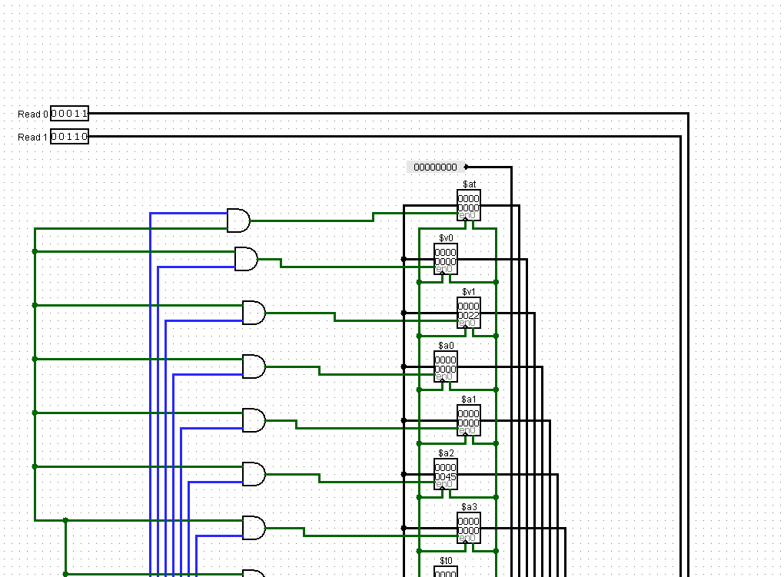

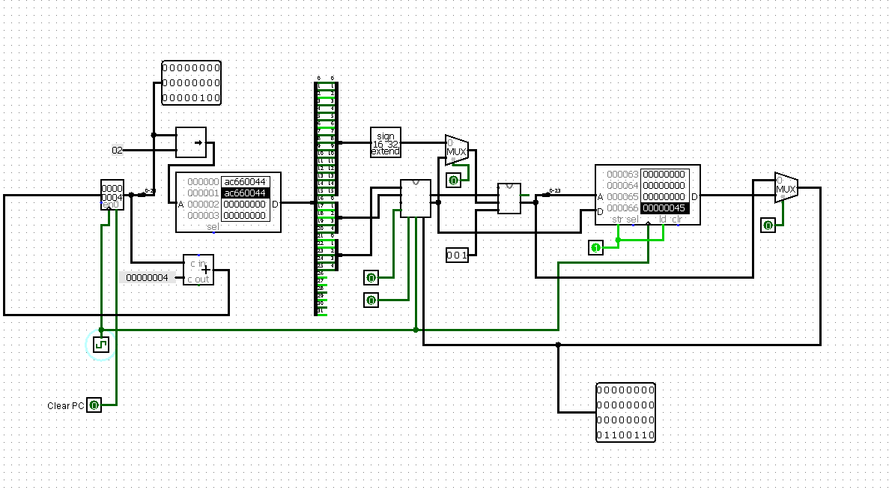

1. **addi, $2, $0, 5, - (add immediate)**

**Binary Code – 001000-00000-00010-0000-0000-0000-0101**

**Machine Code: 20020005**

$2 = $0 + 5. I.e, register 2 will get the value of the sum of 5 and value in register 0 (always 0). Here $0 always has 0 in it. So $2 should be updated with 5. Register 0 has value 0 in it as shown below. Also, $2 has value 0 in it.

Before Machine Code Instruction

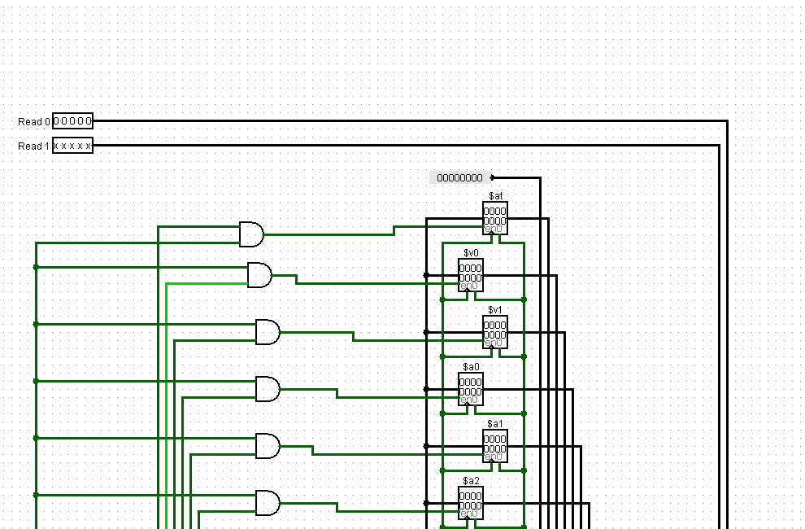

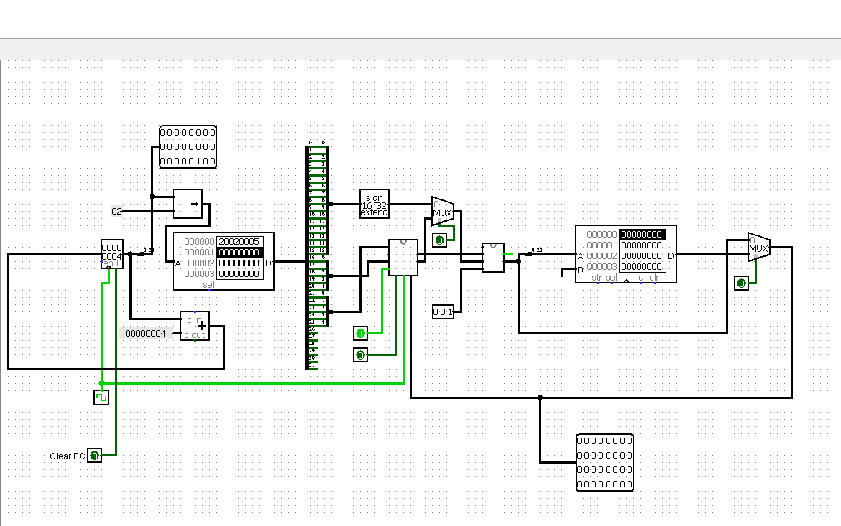

After Machine Code instruction

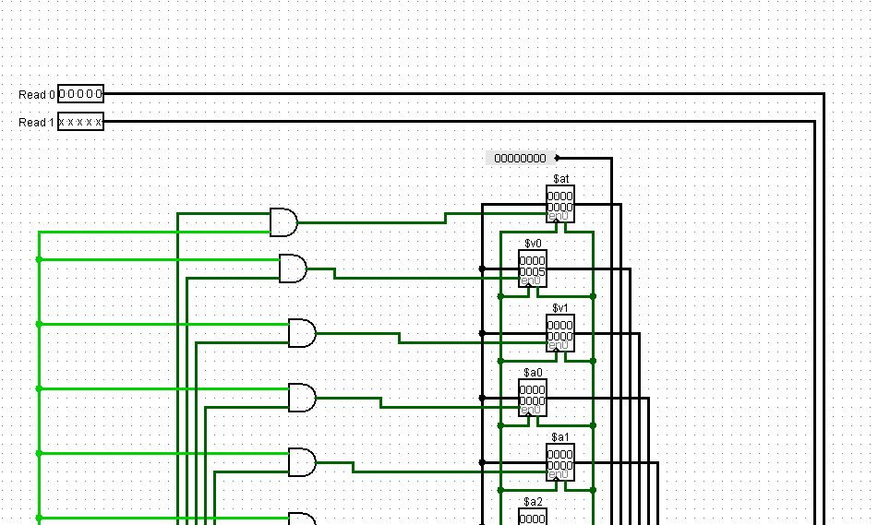

1. **ori $2, $0, 5 - (or immediate)**

**Binary Code: 001101-00000-00002-0000-0000-0000-0005**

**Machine Code: 34020005**

Before executing instruction



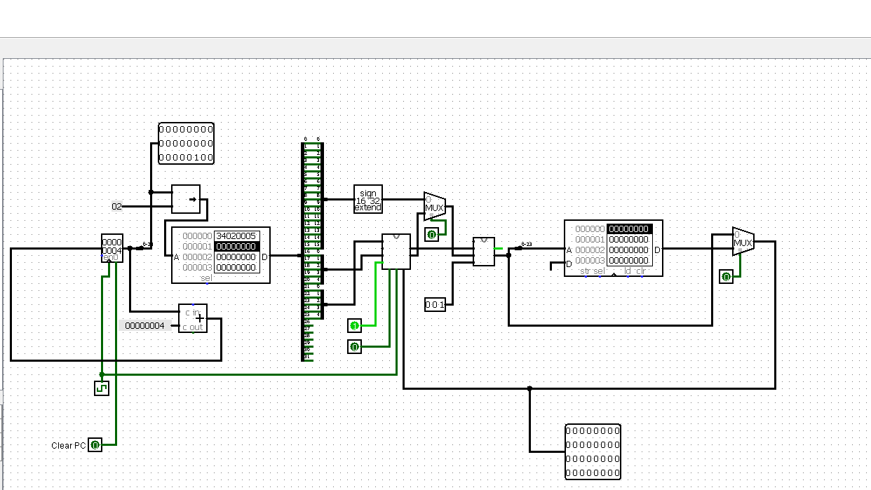

After Executing Instruction



It stores or operation between register $0 and value 5 in register $2. $2 = $0 or 5. Here $0 always has 0 in it. So $2 will ultimately get 5 in it. Initially, $2 has value 0 in it. And $0 always has 0 value.